Part A – Language Description

Introduction to Java
Java is a versatile, class-oriented programming language created with a strong focus on portability, security, and dependability. While it is rooted in the object-oriented programming model, it also integrates certain procedural and functional elements. Since its debut in 1995, Java has become a cornerstone for enterprise solutions, web development, mobile applications, and large-scale distributed systems. One of its hallmark features is platform independence, made possible through the Java Virtual Machine (JVM), encapsulated in the motto “Write Once, Run Anywhere.”

History of the Java Language
In the early 1990s, James Gosling and his colleagues at Sun Microsystems initiated the Green Project, with the goal of designing a dependable and portable programming language for use in embedded systems and consumer electronics. The language, first called Oak, was later renamed Java and officially launched in 1995, coinciding with the rapid expansion of internet-based applications.
Java quickly gained popularity due to its streamlined memory management and its deliberate exclusion of unsafe constructs found in older languages like C and C++. Following Oracle Corporation’s acquisition of Sun Microsystems in 2010, stewardship of Java shifted to Oracle. Since then, the language has continued to evolve through regular updates, incorporating innovations such as lambda expressions, modular architecture, and improved runtime efficiency.

Influences on Java and Languages Influenced by Java
Influences on Java
Java’s syntax and control mechanisms draw heavily from C and C++, which made it approachable for developers already experienced with those languages. At the same time, Java intentionally excluded elements like pointer arithmetic and multiple inheritance to enhance both safety and ease of maintenance. Its object-oriented principles also show inspiration from Smalltalk, especially in the focus on encapsulation and the dynamic interaction between objects.

Languages Influenced by Java
Java has played a major role in shaping the development of later programming languages. C# mirrored much of Java’s syntax and object-oriented framework, while JVM-based languages like Kotlin, Scala, and Groovy were created to operate within the Java environment. These languages build upon Java’s foundation by adding features such as functional programming yet remain interoperable with the broader Java ecosystem.

Comparative Analysis of Java, C++, and Python
To provide a fair and technically sound assessment, Java is compared with C++ and Python. Each of these languages embodies distinct paradigms, execution strategies, and design principles. This comparative approach enables Java’s features to be evaluated within context rather than portrayed as inherently superior.

Technical Comparison of Java, C++, and Python
Aspect | Java | C++ | Python
Primary Paradigm | Object-oriented with procedural and functional support | Multi-paradigm (procedural, object-oriented, generic) | Multi-paradigm (procedural, object-oriented, functional)
Typing System | Static, strong typing | Static, strong typing | Dynamic typing
Memory Management | Automatic garbage collection | Manual memory management | Automatic garbage collection
Execution Model | Hybrid (bytecode on JVM with JIT compilation) | Ahead-of-time compilation to native code | Interpreted with bytecode execution
Platform Dependency | Platform-independent via JVM | Platform-dependent | Platform-independent via interpreter
Performance Characteristics | High, near-native with JIT | Very high, native execution | Lower, prioritises developer productivity
Syntax Complexity | Verbose but structured | Complex and low-level | Simple and concise
Error Detection | Primarily compile-time | Primarily compile-time | Primarily runtime
Security Model | Runtime verification and sandboxing | Programmer-managed | Limited built-in enforcement
Typical Domains | Enterprise systems, Android, backend services | Systems software, embedded and real-time systems | Scripting, automation, data science

Java can be meaningfully assessed by contrasting it with C++ and Python, which embody distinct philosophies in programming language design. Both Java and C++ use static typing with rigorous compile-time checks, whereas Python employs dynamic typing to emphasize flexibility and rapid development. Java enforces a more disciplined object-oriented model compared to C++, which permits low-level procedural features; this enhances consistency and maintainability, though it often results in more verbose code.
From an execution standpoint, Java’s hybrid approach combines portability and efficiency through bytecode interpretation and Just-In-Time (JIT) compilation. C++ achieves maximum performance by compiling directly into native machine code, while Python prioritizes simplicity and developer productivity over runtime speed. Memory management also differs: Java and Python utilize automatic garbage collection to minimize memory-related issues, while C++ relies on manual management, offering greater control but higher risk. In practice, Java occupies a middle ground, delivering stronger safety and portability than C++ and more reliable performance than Python.

Compilation and Interpretation Process
Java uses a mixed compilation strategy that blends both compiling and interpreting. When developers write Java code, it is first translated by the compiler into bytecode, a platform-neutral format. The Java Virtual Machine (JVM) then executes this bytecode either by interpreting it directly or by converting it into native machine instructions through Just-In-Time (JIT) compilation. This dual process ensures that Java applications maintain cross-platform portability while delivering strong runtime efficiency.

Uses of Java in Industry
Java remains a dominant programming language across diverse industries thanks to its scalability, reliability, and rich library ecosystem. In enterprise settings, it is a preferred choice for building backend infrastructures and web services, especially within banking and financial domains where security and dependability are paramount. Beyond this, Java is integral to Android app development and is widely employed in cloud computing and big data solutions. Its enduring stability, coupled with strong community backing, has ensured its ongoing importance in the technology landscape.

Compilation and Runtime Features
Java incorporates a range of runtime mechanisms designed to improve reliability and security. Its automatic garbage collection system helps prevent memory-related faults, while strong static typing enables many errors to be identified during compilation. Furthermore, the Java Virtual Machine (JVM) verifies bytecode prior to execution, ensuring compliance with safety rules. Together, these features make Java particularly effective for developing large-scale and security-critical applications.

Syntax and Semantics of Java
Java syntax is explicitly defined and structured around classes and methods. Programs begin execution from the main method, and variables must be declared with explicit types. This static typing system promotes program clarity and reduces runtime errors.
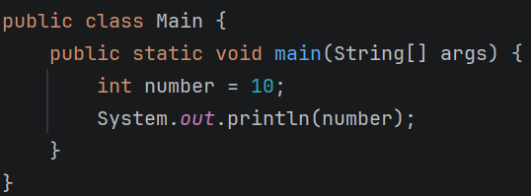

From a semantic perspective, the program establishes a class, introduces an integer variable, and displays its value. Java’s semantic model is rooted in object-oriented concepts such as encapsulation, inheritance, and polymorphism, which collectively foster modular design and maintainable software systems.

Lexical Analysis in Java
Lexical analysis marks the initial phase of Java’s compilation process. In this step, the compiler examines the source code and breaks it down into tokens that represent elements such as keywords, identifiers, literals, operators, and separators. Reserved words like class, public, and static carry fixed meanings and cannot serve as identifiers. Whitespace and comments are typically disregarded, except when needed to distinguish tokens. This systematic lexical processing supports precise syntax parsing and helps identify programming errors early on.

Part B - Software programming environment & software design

Programming Environment Setup
The application is built with IntelliJ IDEA Community Edition, an integrated development environment offering comprehensive support for Java development, including editing, compiling, running, and debugging code. IntelliJ IDEA streamlines project setup by automatically recognizing installed Java Development Kits and handling build processes internally. The environment has been properly configured, and Java programs compile and run smoothly within the IDE.
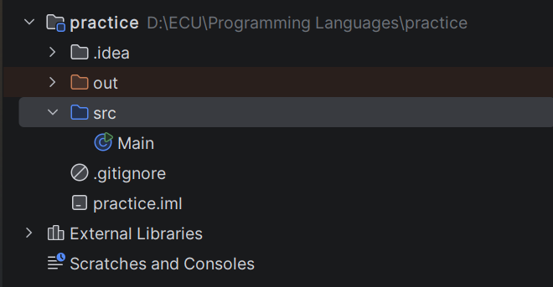

Java Version Selection
The application is developed with Java SE 21, a Long-Term Support (LTS) edition maintained by Oracle. This version was chosen for its combination of enhanced performance, modern language capabilities, and long-term reliability. As an LTS release, Java 21 benefits from extended security patches and continuous maintenance, making it appropriate for both academic projects and enterprise-scale applications. Employing a stable and widely supported Java version ensures consistent operation across platforms while reducing compatibility challenges during development and deployment.
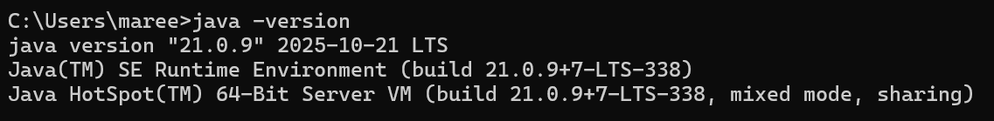

Version Control and GitHub
Version control for the project is handled through Git, with the repository hosted on GitHub. GitHub facilitates structured tracking of code modifications, allows restoration to earlier versions, and serves as a central hub for source code storage. Even though the project is developed independently, GitHub supports professional practices such as incremental development, detailed commit histories, and potential collaboration. Leveraging GitHub ensures alignment with industry-standard workflows and enhances the maintainability of the codebase.

